**Commodity Management Module Setup Guide**

This document outlines the necessary steps for installation of Commodity Management (CM) module. The NMRS module is a prerequisite for the installation of the CM module. it is expected to have the NMRS module installed before the CM module can be installed.

**Requirements**

To install the commodity management module, it is strongly recommended to update the NigeriaMRS modules to the latest optimized version. Kindly ensure that the following modules have been updated to the latest versions listed below:

* NMRS 2.0 modules

nigeriaemr-1.4.1-SNAPSHOT.omod

nmrsclinicals-1.0.1. omod

dataquality-1.0.1-SNAPSHOT.omod

datamigration-1.0.1-SNAPSHOT.omod

patientflags-3.0.2-SNAPSHOT.omod

* All inventory modules
* jasperreport-2.0.0
* openhmis.backboneforms-3.0.0
* openhmis.cashier-4.0.0
* openhmis.commons-4.0.0
* openhmis.inventory-3.3.1-SNAPSHOT

**Step 1. Modify database (Do this before you deploy the inventory modules)**

* On your database setup, run the following script

ALTER DATABASE `YOUR_DBNAME`

DEFAULT CHARACTER SET utf8

DEFAULT COLLATE utf8_general_ci;

**Step 2. Deploy Inventory Modules**

* Navigate to the path where the NMRS modules is located as seen in the screenshot below

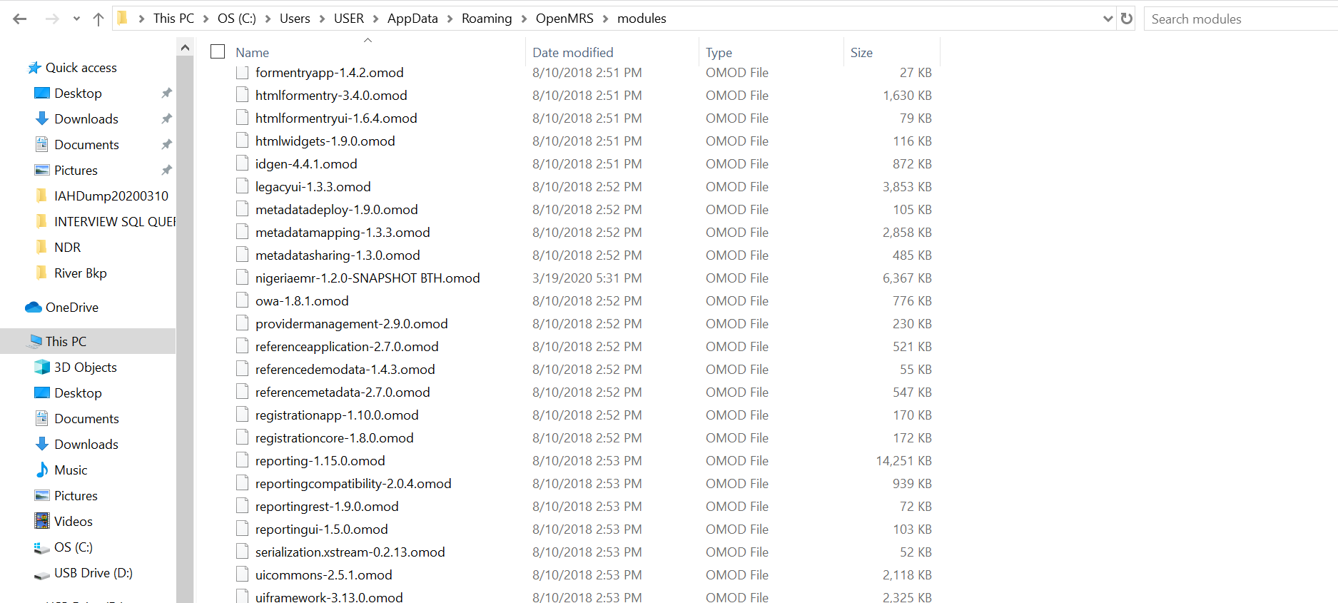

* Paste all required inventory modules into the designated path

**Setup 3. Launch Nigeriamrs Module**

* Startup apache Tomcat service
* Launch Nigeriamrs from the browser via localhost:8080/Openmrs
* Provide login details

**Commodity Management Module Update**

Users who already have the commodity management module installed, should ensure that the NigeriaMRS module has been updated to the latest optimized version with the modules stated above. You are also required to upgrade the inventory module on your module folder to “openhmis.inventory-3.3.1-SNAPSHOT”.